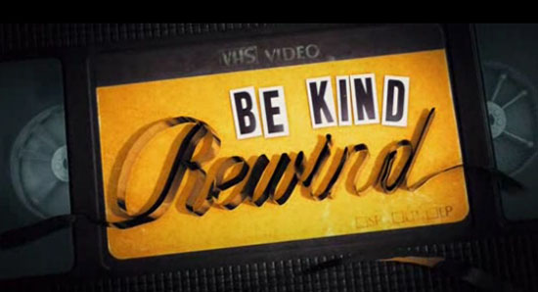Movie Project

In the movie *Be Kind Rewind*, Jack Black and Mos Def recreate movies using cruddy camera equipment and poorly constructed special effects after an entire video store worth of movies is erased in a freak “magnetic man” accident. They refer to this process as “sweding,” and sweding has become a bit of an Internet phenomenon.

For this project, you will be working with a group to create a script for a sweded film. Although in the movie no script was required, this is—unfortunately—a class and so you will be expected to put some degree of thought into your project.

**Here is your grading criteria:**

1. Length – movie should be between 3-5 minutes. Any longer and you’re working too hard (although it may be acceptable).
2. Theme/Argument – the movie should convey the same basic points as the original. 50 points
3. Script – you need to write a script.
4. Your analysis paper – You should write a paper (detailed below) describing the rhetorical decisions you’ve made, changes you had to make to the script, etc. This is a required assignment for the course and the most serious part of the project.

**So, here’s what you need to do:**

1. Pick a movie with your group that you believe you can recreate using existing camera equipment (cell phones, cameras you own, or mine in class).
2. Make a list of the scenes you believe are necessary to convey the basic mood, theme, and argument of the movie. Be prepared to defend your choices.
3. Write a script and think of common everyday items that you could use to convey the scene, characters, and props necessary to the movie. Collect them.
4. Practice, if necessary.
5. Film.
6. Edit—though not too much. It’s fun to look professional, but remember that you can look *unprofessional* and leave in mistakes, that’s part of the fun of sweding. Editing can be done on Windows Movie Maker, iMovie, or other free software.

**So why are we doing this?**

That’s probably a good question. I believe that there are many assignments that could teach rhetoric by “any means necessary” and could be used to kick off a class about using technology, graphic design, speaking, and multimedia all at once, but I wanted to pick something that was A) fun and B) could make something that was displayable outside of the class. The practice of using more than simply writing or speech in argumentative situations is not one to be taken lightly, however, I’ve found that fun assignments do just as well to teach as really boring ones.